## note

|  |  |  |
| --- | --- | --- |
| Eye glasses  spectacles | ˈspektək(ə)lz/ | optical instrument consisting of a pair of lenses for correcting defective vision |
| Persuasive  Convinced  belief | /pəˈsweɪsɪv/ | tending or intended or having the power to induce action or belief  A persuasive argument, the evidence is persuasive but not conclusive |
|  |  |  |
|  |  |  |
|  |  |  |
|  |  |  |

# Lesson

https://www.cambly.com/en/student/courses/5eb03d0f9934e038cfcf0372/5eb03d451bfbfd36bafad4ef

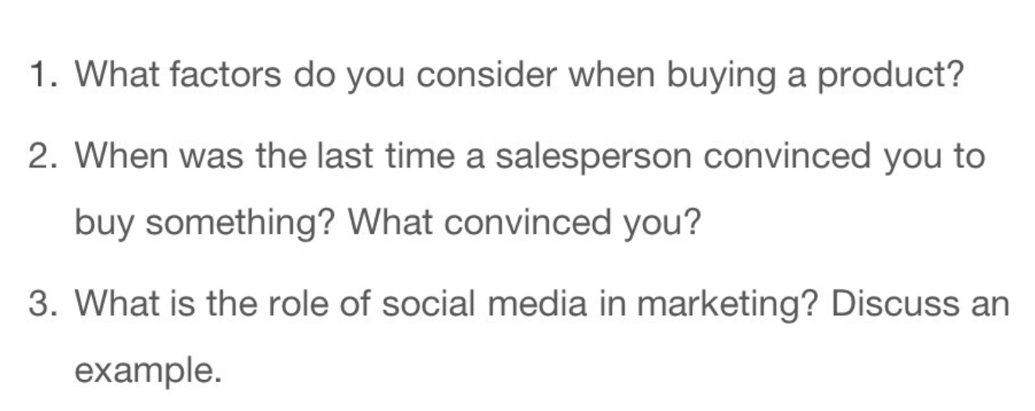

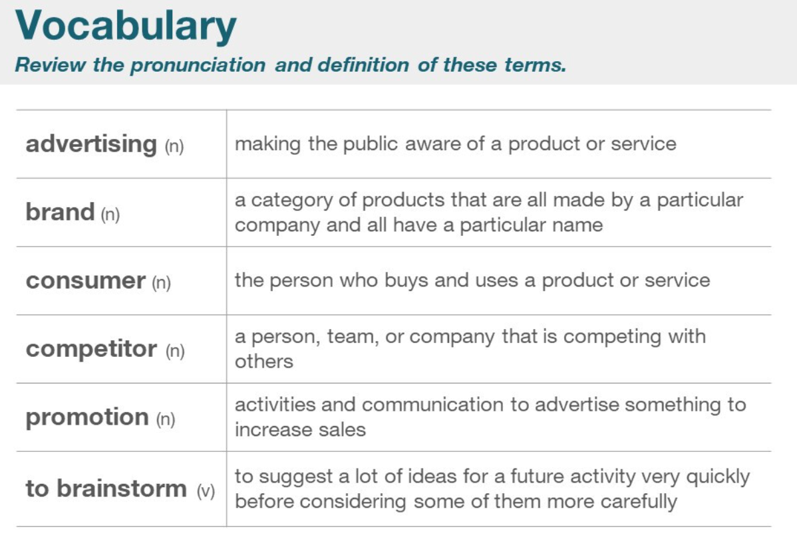

|  |  |  |
| --- | --- | --- |
| selasperson |  |  |
| Advertising  Seller <> secret  announcement |  |  |
| brand |  | Particular name |
| Consumer  Customer |  |  |
| competitor |  |  |
| promotion |  |  |
| To brainstorm  Problem-solve / ignore |  | Quickly thinking before doing |
| Competitive advantage  Challenger <> ally |  |  |
| Market leader |  |  |
| Product launch |  |  |
| Public relations |  |  |
| Target market |  |  |

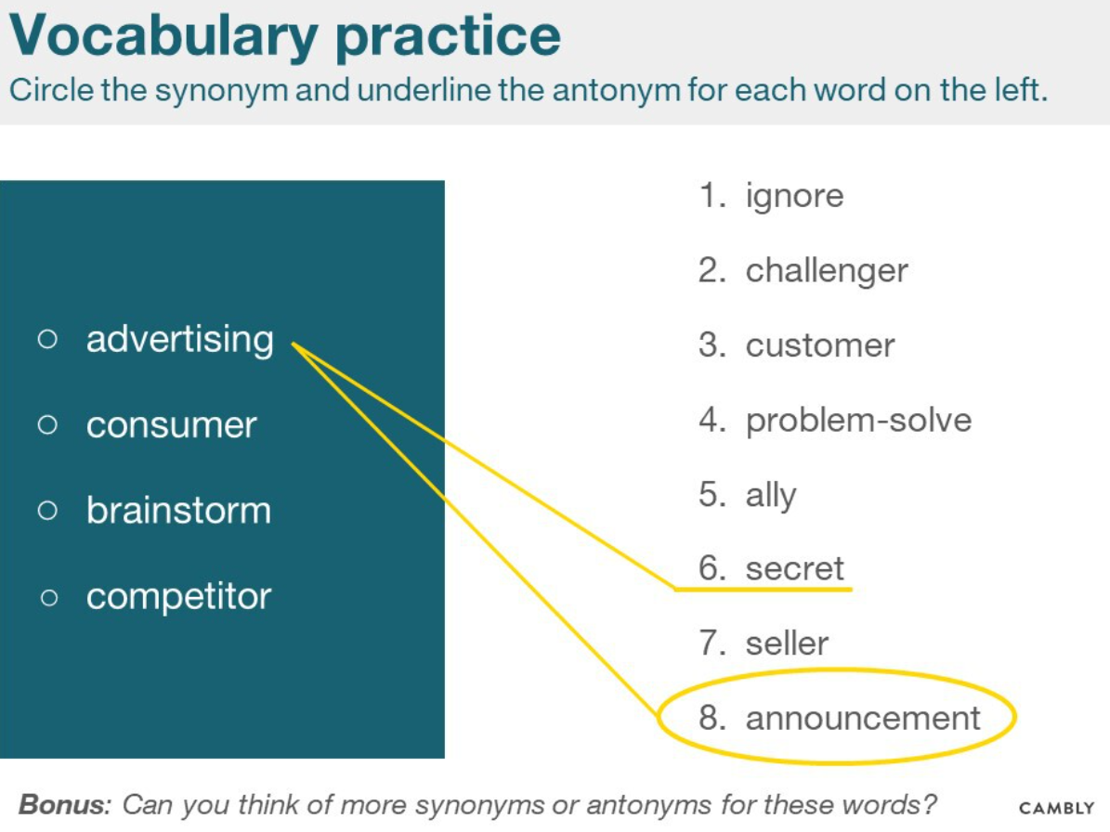

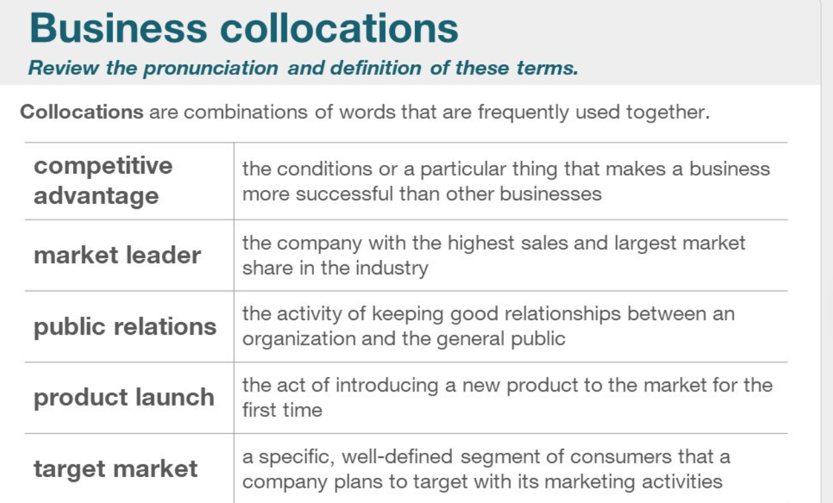

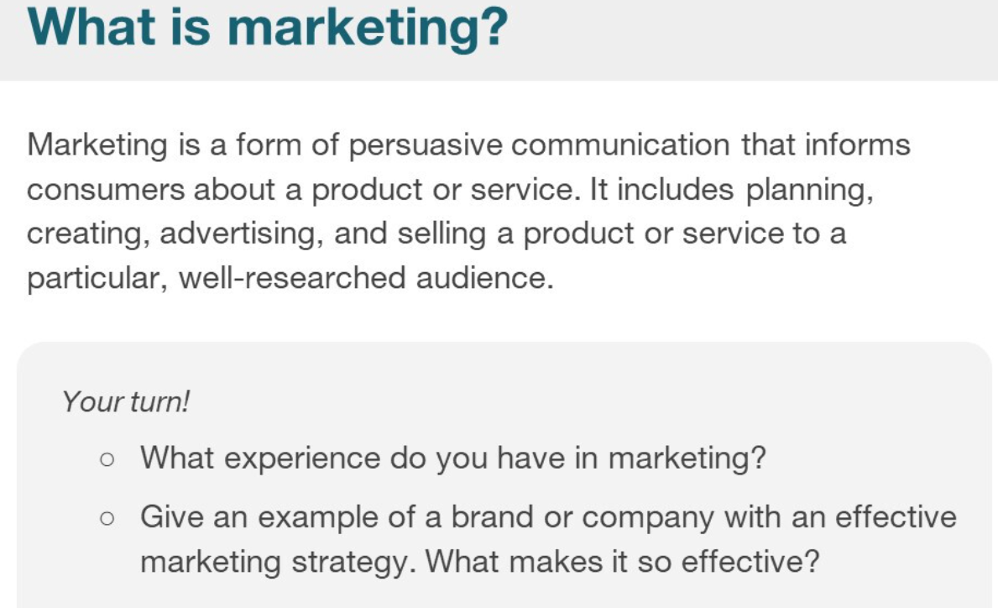

|  |  |  |
| --- | --- | --- |
| particular |  |  |
| Businesses  services |  |  |
| Avenues  Main street | /ˈævənjuːs |  |
| category |  |  |
| Loyalty incentives |  |  |

